GLOBAL PRAYER NET
Partnering through Prayer for Global Transformation
June 30, 2020
MISSIONARY PRAYER FOCUS
Global Partners is asking for focused prayer this week for Greg Edmonds, missionary to Haiti.
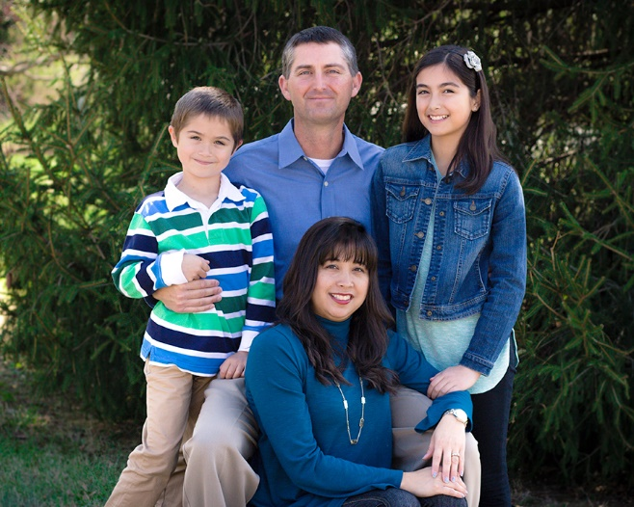
Greg and his wife, Heidi, served for three years with Global Partners as missionaries to Haiti following the 2010 earthquake. Greg served as compound manager and oversaw the construction of the new La Gonave Guesthouse and Ministry Center. Heidi trained the guesthouse staff, and together they helped host over 100 short-term mission teams.
In early 2016 God reminded Greg about the clear call to missions that he received while serving on a mission trip to Nicaragua in 2009. God impressed this thought on Greg's heart that day, "You were born in America so you can do exactly what you are doing right now . . . reaching out to those less fortunate in my name."
Global Partners appointed Greg as a missionary in October 2016. His first assignment was to recruit and lead mission teams to Haiti to rebuild the churches that were destroyed in the October 2016 hurricane. Greg is the current Caribe-Atlantic Area Missionary Team Leader.
Greg and Heidi have two children: Haley (’05) and Luke (’10).
Prayer Points from Greg Edmonds:
- Pray for local church pastors and leaders as they deal with the realities of ministry during COVID-19. Pray that God would use the church to minister his love and grace in this unique time to see revival come to Haiti.
- As we feared, COVID-19 has finally started spreading rapidly in Haiti. Pray for a quick end to the spread of the virus. Pray for healthcare workers at the La Gonave Wesleyan Hospital as they minister to the sick and dying with the love of Christ. One missionary couple reported that they are surrounded by people with symptoms.
- Pray for the Wesleyan hospital as we work to set up an auxiliary that will help fund the hospital for many years to come.
- Pray for the La Gonave School of Nursing since we have suspended classes due to COVID-19.
- Pray for rains to be consistent during the summer and fall in order to increase crop production. The rising cost of food and the lack of food in places has prompted some international organizations to predict a "famine of Biblical proportions" in Haiti.
Find Greg Edmonds on the Global Partners website
at globalpartnersonline.org/missionary/wm29-0105/

Email:
greg.edmonds@gponline.org

